**# Setting Up the System**

Now that you have all four RPi's setup with the software, as well as the PC set up we can hook up the ethernet cables.

-Turn off wifi on the host PC

-The only ports that you should be using on the gigabit routers are ones that have numbers next to them and are not WAN or LINK ports

-Have the PC hook up to 1 on the gigabit router. Then hook up RPi's 1, 2, 3 and 4 repectively if you have enough ports on your gigabit router

-If you only have 2 gigabit routers hook an ethernet cable as an intermediate between both routers and plug in the rest of the ethernet cables with the RPis

The RPis need at least 2 Amps of current each to operate, however 3 Amps is preferred if possible.

-Make sure the NoIR cameras are inserted properly. The blue tab should be facing towards the Ethernet port on the RPis

4 RPi's Connected via ethernet with NoIR cameras set up.


The RPi’s set up

**# Running the System**

-Type 'cmd' into the Windows search bar and click on the Command Prompt application that shows up.

-Type in:

'''

> cd Downloads\VideoAPA-Rep-6-2020\VideoAPA_For_Host_PC\acquisition

> runacquistion.bat

'''

1. **Operation Instructions:**

6.1. Navigating the Software:

1. Run the runacquisition batch file. The following window (see Figure 1) should appear:

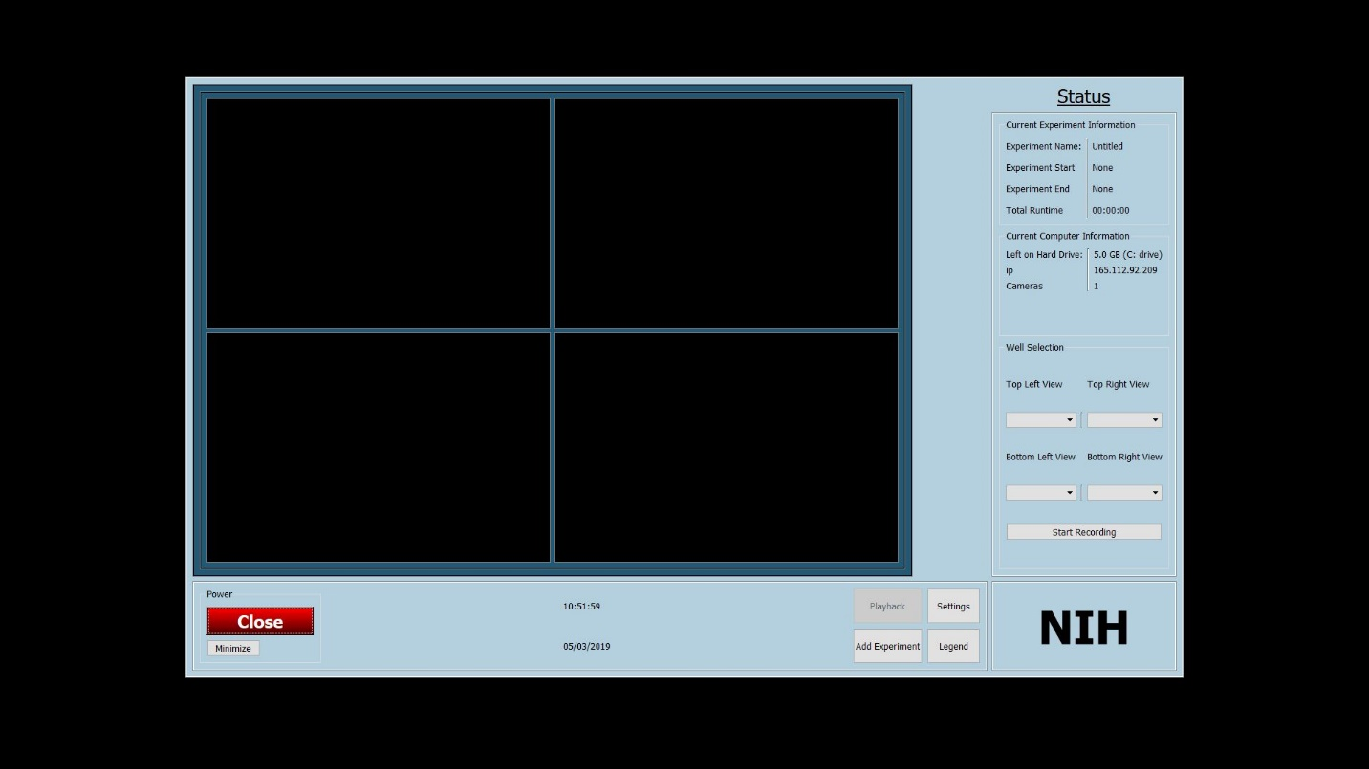

Figure : View of GUI at launch

6.2. Changing Settings:

1. From the main menu, click on Settings. The following window (see Figure 2) should appear.

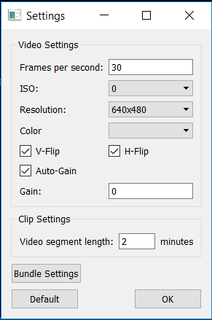

Figure : Settings menu GUI

1. On this settings menu, the user can change settings such as frames per second (fps), ISO, and resolution. The user is also able to set the length for each video segment.

6.3. Bundling Cameras:

1. From the settings menu, click “Bundle Settings.” The following window (see Figure 3) should appear:

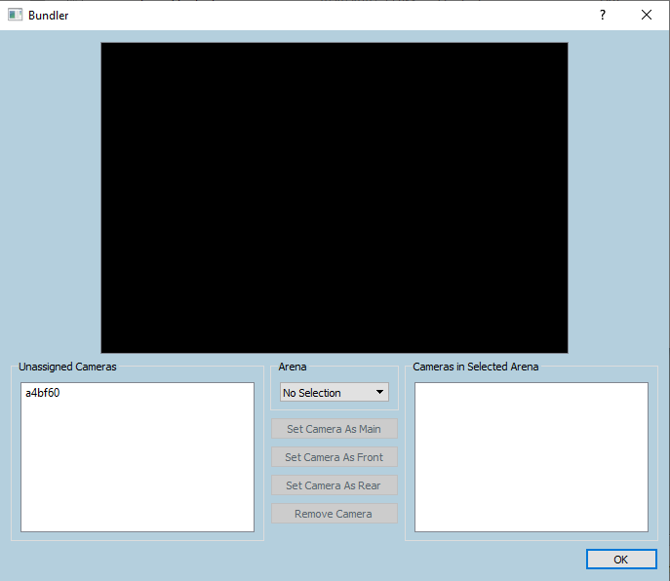

Figure : Sample View of Bundler GUI for grouping cameras

1. In the dropdown menu in the middle of the screen, select “Add Arena.” A window will allow the user to define a name for the arena.
2. In the same dropdown menu, select the newly defined arena.
3. Select the desired camera ID on the left side of the window. A preview (see Figure 4) should appear.   
   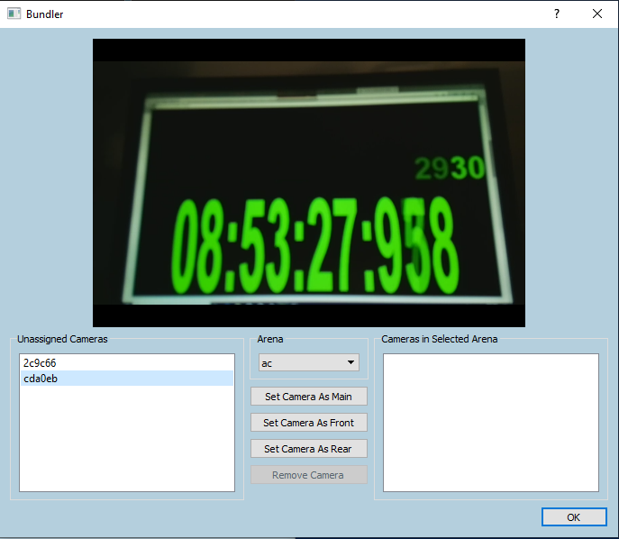

Figure : Camera stream preview on Bundler GUI

1. To assign the selected camera to the selected arena, click “Set Camera as Main,” “Set Camera as Front,” or “Set Camera as Rear.” This will allow you to assign which view you can see.
2. Repeat steps 3-5 to add each desired arena/camera.

6.4. Unbundling Cameras from Arenas:

1. From the main menu, click the “Settings” button (See Figure 1, Settings is in the bottom right corner).
2. On the settings window, click “Bundle Cameras” (See Figure 2).
3. In the dropdown menu in the middle of the page, select the arena name you want to unbundle from the camera (See Figure 4).
4. Select the camera you would like to remove from the bundle from the list under “Cameras in Selected Arena”.
5. Press “Remove Camera” to remove the camera from the bundle.
6. To remove an Arena from the list, use the dropdown menu in the middle of the Bundler window to select “Delete Arena” and select the arena to delete from the list that appears.
7. Repeat steps 3-6 for each desired camera/arena pair.

6.5. Previewing Active Cameras:

Once cameras are bundled as arenas, the user will be able to preview up to 4 video streams in the main GUI window. Each quadrant of the main GUI’s live preview display is controlled by each of the 4 corresponding dropdown menus in the lower right side of the GUI window (See Figure 5 for an enlarged image of the camera selection section in the main GUI). The user can set each preview quadrant to any of the active arenas to view a live video stream from the arena’s “main” camera. Once a quadrant is set to preview an arena, it can be changed to another arena at any time by the user.

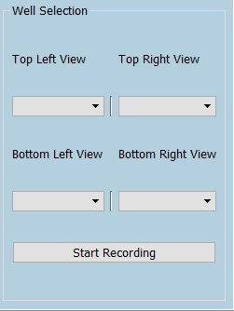

Figure : Camera stream selection section of main GUI

6.6. Starting an Experiment:

1. From the main menu, click on Add Experiment. The following window as show in Figure 6 will open.  
     
   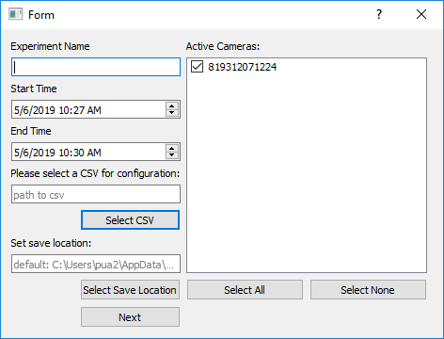

Figure : GUI for defining an experiment

1. The left panel allows the user to set the experiment name, start/finish times, and save location. The right panel allows the user to select which cameras to record video from.
2. If the experiment is set incorrectly (e.g. the start time is before the end time but after the current time, etc.), the user will be prompted to fix the experiment parameters.
3. The software will initiate recording automatically at the start time. Likewise, the software will automatically terminate recording at the end time. If the user would like the start or finish early, they can manually use the “Start/Stop Recording” button in the lower right-hand corner of the main GUI.